Rolling correlation: NZDUSD and USDCAD
Method 05 / daily log returns / windows 20, 60, 100 / Short watchlist

Study setup
Logical pair: NZDUSD , USDCAD
Broker symbols: NZDUSD_i , USDCAD_i
Tier: Short watchlist (short_watchlist)
Snapshot: 2026-11-03_majors_alpari_D1
Timeframe: D1
Matched return window: 1999-01-05 to 2026-11-02 (UTC bar dates)
Matched return count (rows before rolling): 7190
Dropped unfinished last bar dated 2026-11-03 UTC after a tick-volume check against the prior complete day.
Rolling windows W: 20, 60, 100 trading days
Live-shaped n for each score: n = W (not the full history length)
Complete matched rows (CSV): NZDUSD-USDCAD_Rolling_D1.csv
Complete matched rows (HTML): NZDUSD-USDCAD_Rolling_D1_data.html

Method carried forward
Rolling Pearson r is computed on matched daily log returns of close, ln(close_t / close_t-1), in the broker quote direction. Quotes are not inverted. For each day t with a full window, r_W uses the last W matched return pairs ending at t. That live-shaped sample size is W (20, 60, or 100), not the full multi-year history. The first W-1 days have no score. r is symmetric under swap of the two symbols. A high |r| in one window does not prove cause, lead-lag, or a trading signal. Short windows are noisier; long windows are slower to reflect a break.
How to read a live day: after both daily candles close, the newest r_20 uses the last 20 matched log returns, r_60 the last 60, and r_100 the last 100. Compare those three to each other and to the full-sample baseline below. A break is when the short window moves far from the baseline or flips sign while the baseline was meaningful.

Full-sample Pearson baseline (method 01 v001)
Copied full-sample Pearson r for NZDUSD-USDCAD: -0.587831. This is a historical average link, not the live state.

Rolling results
W | latest_r | mean | median | min | max | std | pct_|r|>=0.4 | pct_|r|>=0.7 | n_roll
20 | -0.398148 | -0.532638 | -0.572563 | -0.966256 | 0.777517 | 0.230846 | 74.72 | 25.42 | 7171
60 | -0.530855 | -0.542275 | -0.573596 | -0.894436 | 0.091842 | 0.175822 | 78.5 | 18.69 | 7131
100 | -0.564059 | -0.546341 | -0.574347 | -0.860301 | -0.008377 | 0.162925 | 80.14 | 19.14 | 7091
n_roll is the number of days that had a complete window. pct_|r|>=0.4 and pct_|r|>=0.7 are the share of those days where the absolute rolling correlation cleared the threshold.

Conclusion
For NZDUSD and USDCAD, full-sample Pearson baseline r=-0.5878. Latest rolling scores: r_20=-0.3981, r_60=-0.5309, r_100=-0.5641. Stability: moderate window-to-window variation. Agreement with baseline: r_20=-0.398 near baseline; r_60=-0.531 near baseline; r_100=-0.564 near baseline. Tier line: watch — priority pair; monitor r_20 vs r_60/r_100 each day. This is a monitoring summary, not a trade signal.

What to look at in this file next time
1) Latest r_20 vs r_60 vs r_100 in the results table. 2) Whether short-window latest has the same sign as the baseline. 3) The rolling chart for stretches where |r| collapsed. 4) The CSV if you need a different chart later.

Charts
Rolling Pearson r (20 / 60 / 100)
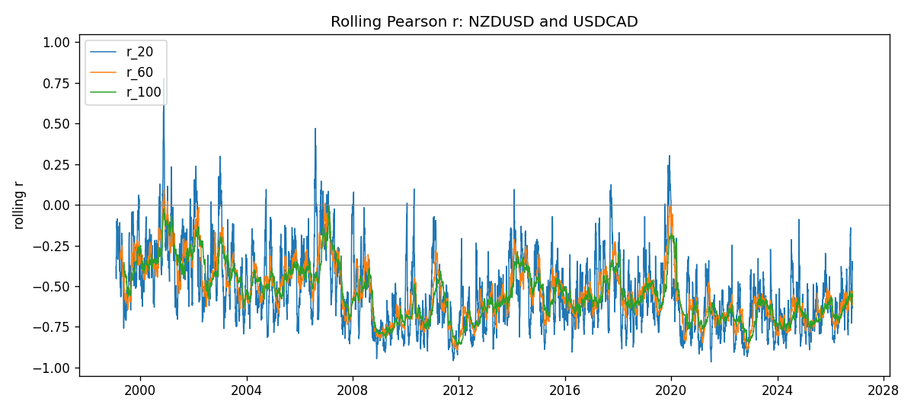
Daily closes

Daily log returns
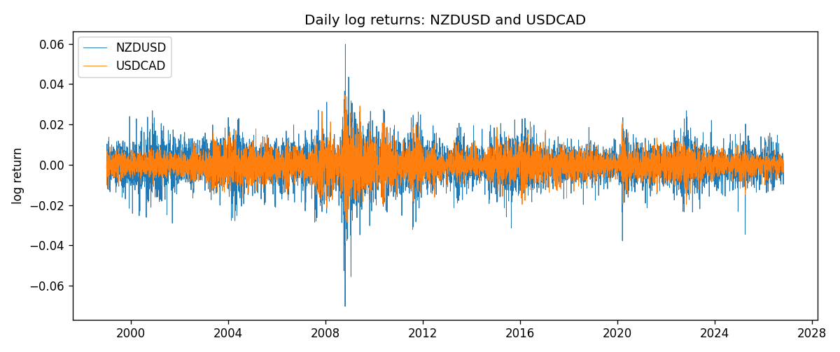

Data report
Every matched row with r_20, r_60, and r_100 is in the sibling CSV and HTML. This Word section holds column summaries and the first and last 15 rows of the rolling table.
Columns: time, NZDUSD_close, USDCAD_close, NZDUSD_tick_volume, USDCAD_tick_volume, NZDUSD_log_return, USDCAD_log_return, r_20, r_60, r_100
Column summaries
column | count | mean | std | min | 25% | 50% | 75% | max
NZDUSD_close | 7190 | 0.656464 | 0.108212 | 0.3907 | 0.591562 | 0.66842 | 0.725015 | 0.8822
USDCAD_close | 7190 | 1.26688 | 0.168951 | 0.916 | 1.11817 | 1.29862 | 1.37243 | 1.6137
NZDUSD_tick_volume | 7190 | 68672.8 | 123110 | 16 | 5561.25 | 33864.5 | 58508 | 1.12768e+06
USDCAD_tick_volume | 7190 | 80995.8 | 147288 | 37 | 5534 | 40938 | 71622.5 | 1.41082e+06
NZDUSD_log_return | 7190 | 6.02e-06 | 0.00764513 | -0.0702743 | -0.00425619 | 0.00022347 | 0.00457637 | 0.0596684
USDCAD_log_return | 7190 | -9.38e-06 | 0.0051433 | -0.0385975 | -0.00283202 | 5.381e-05 | 0.00272817 | 0.0343632
r_20 | 7171 | -0.532638 | 0.230846 | -0.966256 | -0.702784 | -0.572563 | -0.39749 | 0.777517
r_60 | 7131 | -0.542275 | 0.175822 | -0.894436 | -0.673209 | -0.573596 | -0.427394 | 0.0918418
r_100 | 7091 | -0.546341 | 0.162925 | -0.860301 | -0.675284 | -0.574347 | -0.433893 | -0.00837656
First 15 matched rows
time | NZDUSD_close | USDCAD_close | NZDUSD_log_return | USDCAD_log_return | r_20 | r_60 | r_100
1999-01-05 | 0.5372 | 1.5123 | -0.00185977 | -0.0101317
1999-01-06 | 0.5383 | 1.5118 | 0.00204556 | -0.000330677
1999-01-07 | 0.5417 | 1.5141 | 0.00629632 | 0.00152021
1999-01-08 | 0.5414 | 1.511 | -0.000553965 | -0.00204952
1999-01-11 | 0.547 | 1.5057 | 0.0102904 | -0.00351378
1999-01-12 | 0.5441 | 1.5157 | -0.00531575 | 0.00661947
1999-01-13 | 0.5387 | 1.5226 | -0.00997422 | 0.00454202
1999-01-14 | 0.5386 | 1.5332 | -0.000185649 | 0.00693765
1999-01-15 | 0.5382 | 1.5245 | -0.000742942 | -0.00569057
1999-01-18 | 0.5372 | 1.526 | -0.00185977 | 0.000983445
1999-01-19 | 0.5382 | 1.5302 | 0.00185977 | 0.00274851
1999-01-20 | 0.5404 | 1.5211 | 0.00407937 | -0.00596469
1999-01-21 | 0.5426 | 1.5146 | 0.00406279 | -0.00428238
1999-01-22 | 0.5361 | 1.5184 | -0.0120517 | 0.00250577
1999-01-25 | 0.5342 | 1.5197 | -0.00355041 | 0.000855798
Last 15 matched rows
time | NZDUSD_close | USDCAD_close | NZDUSD_log_return | USDCAD_log_return | r_20 | r_60 | r_100
2026-10-13 | 0.56127 | 1.4214 | 0.00473262 | -0.00463957 | -0.575841 | -0.559456 | -0.563265
2026-10-14 | 0.55918 | 1.42356 | -0.00373065 | 0.00151848 | -0.507863 | -0.567204 | -0.595736
2026-10-15 | 0.56185 | 1.41843 | 0.00476349 | -0.00361015 | -0.578403 | -0.59326 | -0.593427
2026-10-16 | 0.56509 | 1.41357 | 0.0057501 | -0.00343221 | -0.64235 | -0.61069 | -0.616944
2026-10-19 | 0.56616 | 1.41091 | 0.00189171 | -0.00188353 | -0.665879 | -0.611127 | -0.610929
2026-10-20 | 0.56827 | 1.40569 | 0.00371993 | -0.0037066 | -0.728352 | -0.616222 | -0.61521
2026-10-21 | 0.57003 | 1.4045 | 0.00309233 | -0.000846918 | -0.718663 | -0.619557 | -0.603595
2026-10-22 | 0.56815 | 1.40081 | -0.00330352 | -0.00263073 | -0.633356 | -0.609078 | -0.594155
2026-10-23 | 0.56991 | 1.40085 | 0.00309299 | 2.85545e-05 | -0.617265 | -0.608005 | -0.592583
2026-10-26 | 0.56826 | 1.40093 | -0.00289939 | 5.71066e-05 | -0.63687 | -0.601944 | -0.594557
2026-10-27 | 0.56811 | 1.40449 | -0.000263999 | 0.00253795 | -0.612295 | -0.612734 | -0.591931
2026-10-28 | 0.56261 | 1.39911 | -0.00972839 | -0.00383793 | -0.347285 | -0.542553 | -0.545256
2026-10-29 | 0.56296 | 1.39895 | 0.000621907 | -0.000114365 | -0.352751 | -0.543319 | -0.563375
2026-10-30 | 0.56307 | 1.39751 | 0.000195377 | -0.00102987 | -0.394922 | -0.52906 | -0.563762
2026-11-02 | 0.56161 | 1.39837 | -0.0025963 | 0.000615191 | -0.398148 | -0.530855 | -0.564059

